Preface and Project Overview
For the purposes of convenience, I decided to temporarily put the “module-7” directory onto my desktop while I tested the codes. The final deliverable will follow the required file structure for the GitHub submission.
The objective of this assignment is to practice unit testing and function refactoring in Python using the unittest framework. By systematically modifying the city_country() function to introduce additional parameters (population and language), this project demonstrates how unit tests detect breaking signature changes (such as missing required positional arguments) and ensure backwards compatibility when optional default values are implemented.
Figure 1: Initial Function Execution
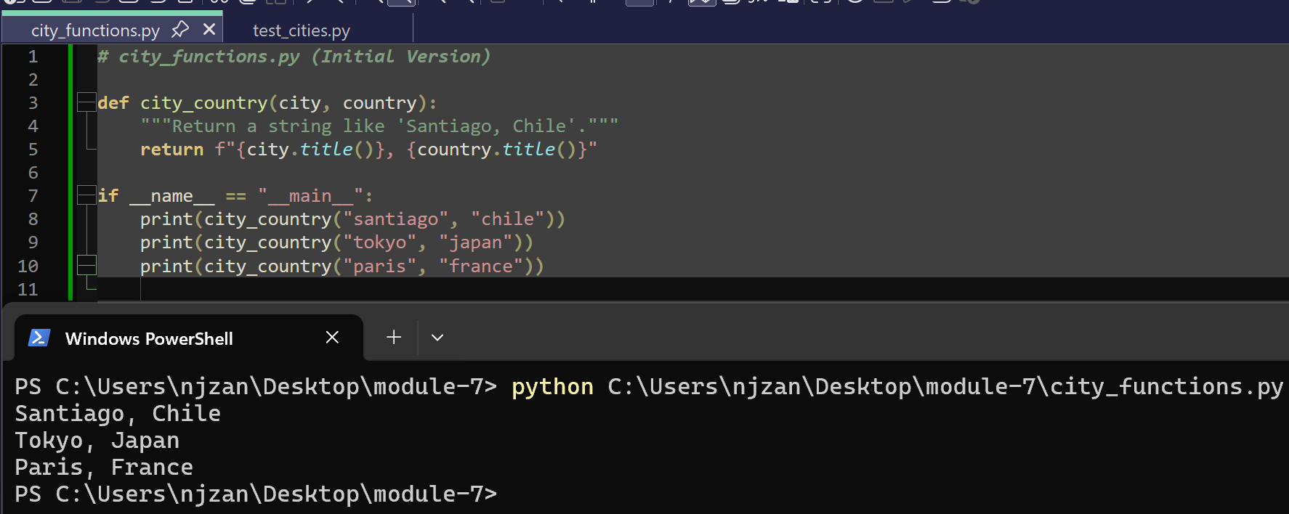
Description: Demonstrates the initial version of city_functions.py containing the city_country() function, which accepts two required parameters (city and country). Executing the script directly calls the function three times and correctly outputs formatted city and country strings ("Santiago, Chile", "Tokyo, Japan", and "Paris, France") to the console.

Figure 2: Initial Unit Test Pass
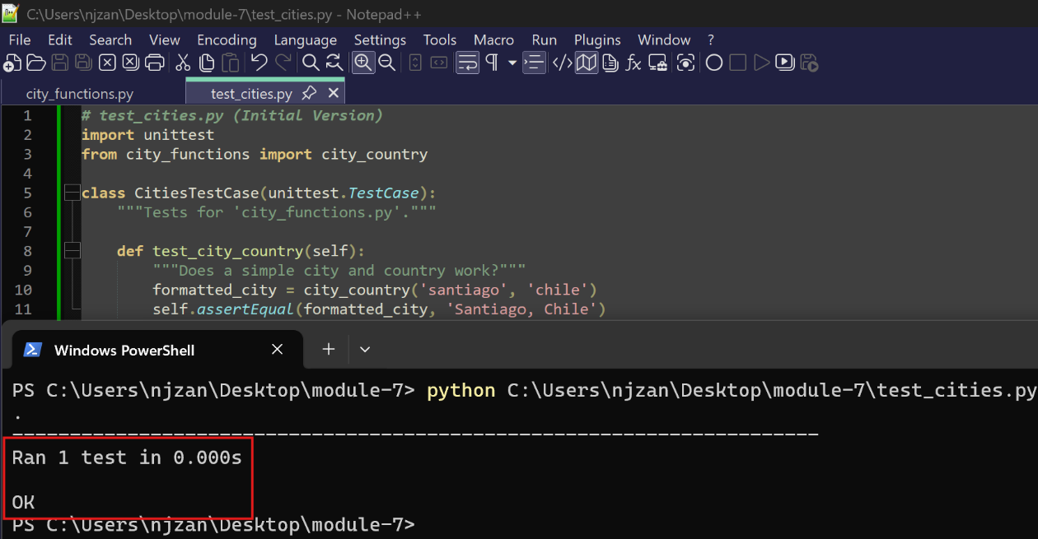
Description: Shows the initial unit test file, test_cities.py, which imports the unittest framework and tests city_country('santiago', 'chile'). Executing test_cities.py results in a passing test status (Ran 1 test in 0.000s - OK), confirming that the function returns the expected string 'Santiago, Chile'.
Figure 3: Breaking Test with Required Population Parameter
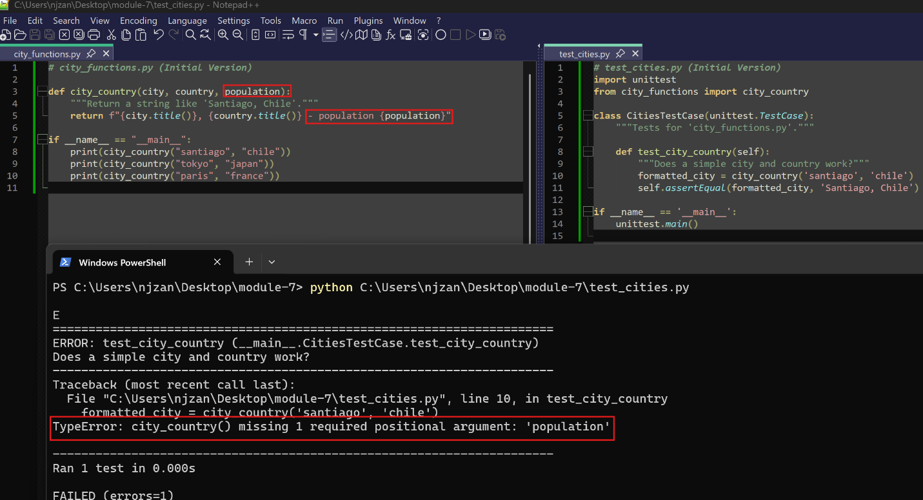
Description: Illustrates city_functions.py modified so that the third parameter, population, is required. When running test_cities.py without passing a population argument, the unit test fails as expected with TypeError: city_country() missing 1 required positional argument: 'population'.
Figure 4: Passing Test with Optional Population Parameter
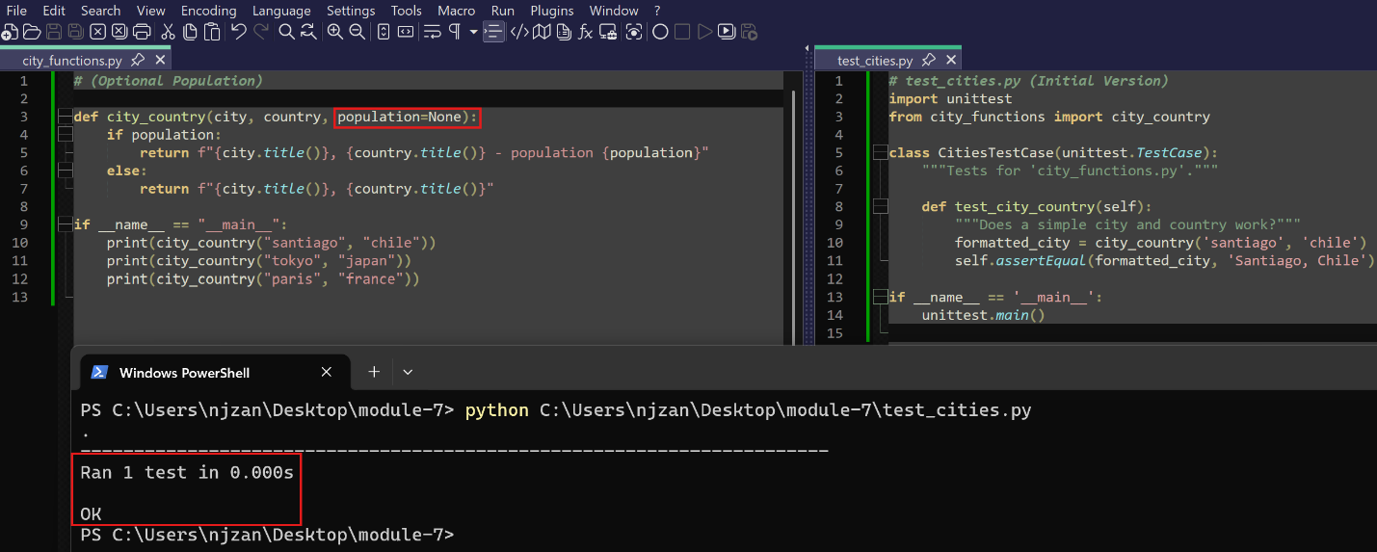
Description: Displays city_functions.py refactored to make population an optional parameter with a default value of None (population=None). Running test_cities.py passes (OK) because calling city_country('santiago', 'chile') without a third argument remains valid.
Figure 5: Breaking Test with Required Language Parameter
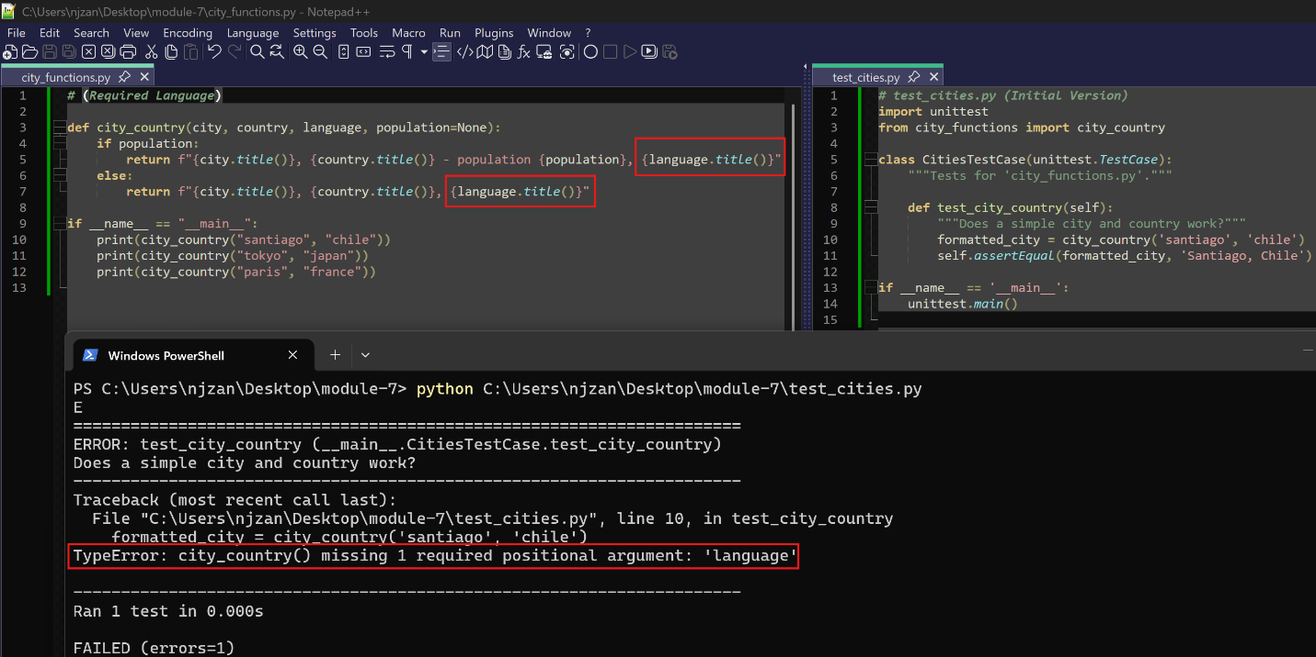
Description: Shows city_functions.py modified to require a language parameter. Running test_cities.py causes the test suite to fail again with TypeError: city_country() missing 1 required positional argument: 'language'.

Figure 6: Final Execution and Test Suite Results
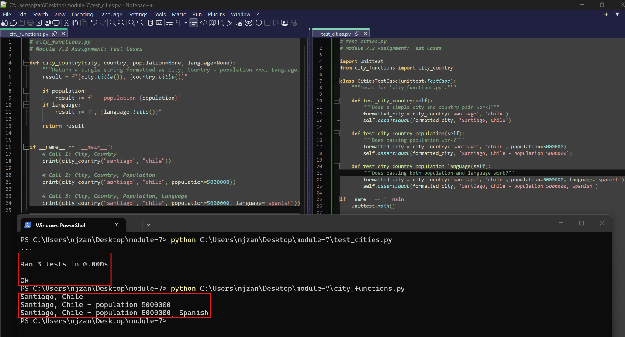
Description: Presents the completed code and terminal outputs for both files:
- city_functions.py: Updated so both population and language are optional parameters (population=None, language=None). Direct execution demonstrates all three call variations (City/Country, City/Country/Population, and City/Country/Population/Language) printing properly formatted output.
- test_cities.py: Expanded to include three distinct unit test methods (test_city_country, test_city_country_population, and test_city_country_population_language). Running the file confirms that all three unit tests pass successfully (Ran 3 tests in 0.000s - OK).

